Semiconductor calculations for CMOS pixel

Full Well capacity
The full well capacity is calculated using the following formula:

Where:
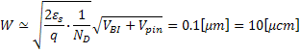
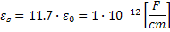
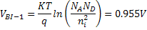
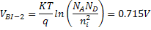
Calculation:
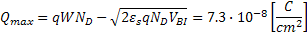

We calculate and achieve the following full well capacity (in number of electrons):

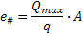

Where the area of the active photo diode is:
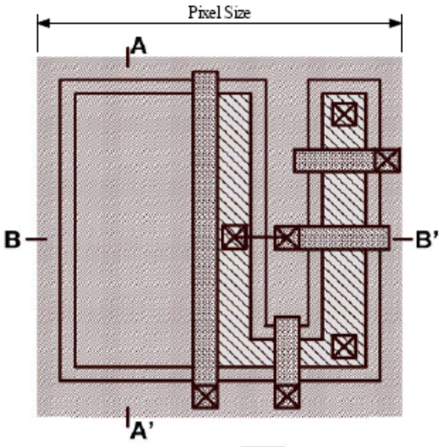
Active
Area

And the maximum number that the pixel can hold is:
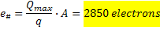
Errors in number of electrons
Dynamic range and SNR
From analog
From digital

Voltage of a single pixel
The voltage of a single pixel will be governed by the following formula:
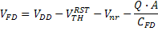
Where the active aria of the pixel is:
Active
Area
Is the area of the active diode surface (reactive to light).
Since we use correlated double sampling.
Is given
Is given
Area

FD
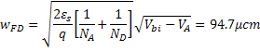
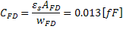
Is the capacitance of the floating diffusion and is the suface area of the capacitor and is the length of the depletion region on the diode structure. Capacitance of this region is usually very low, to achieve high conversion gain, i.e. the change of its potential/voltage with the addition of one electron. The floating diffusion capacitance is typically¹ of the order of but since our pixel is very small we get even a lower value.

Eventually we get (without dark currant):
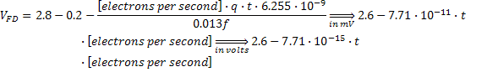
Where
Is exposure time or integration time (part of the second).

Q function

The Q function is the function that translates the number of photons to electric charge to be translated to voltage as the output of the Pixel. We get as an input the watt per second of a single pixel; to translate it to number of electrons we divide it by the energy of one electron, we will get a value of electrons per second, this value will be multiplied by t – sample time (an experimental value).
Q is a function of the number of photons per second, times t (the time for which the pixel is open to receive light) and the electric charge of one electron.

The maximum of this function will be the full well capacity:
And the minimum of this function will be zero or thermal current (dark current).
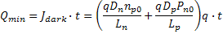
Thus the final formula for voltage will be in the range of the following values:
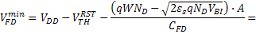
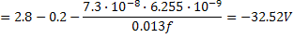
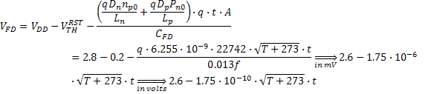

Total voltage from the floating diffusion region will be:
Where
Is exposure time or integration time (part of the second).
Is the temperature of the pixel, in Celsius.

References
- ¹ CMOS Image Sensors: Electronic Camera-On-A-Chip, Eric R. Fossum, IEEE TRANSACTIONS ON ELECTRON DEVICES, VOL. 44, NO. 10, OCTOBER 1997
- O. Yadid-Pecht and R. Etienne- Cummings, "CMOS imagers: from phototransduction to image processing" , Cluwer Academic Publishers, 2004.
- Image Sensors and Signal Processing for Digital Still Cameras, Junichi Nakamura
- http://www.andor.com/learning/digital_cameras/?docid=321

